DIGITAL MARKETING CONCEPTS
- Pick any two apps you use daily (like Instagram, Zomato, or Flipkart) and identify one online marketing technique each app uses to attract new users. Write a short explanation (2-3 lines) for each technique.

1. Instagram – Influencer Marketing
Instagram uses influencers to promote its app and features. Popular influencers share reels and posts that attract new users and encourage them to join Instagram.
2. Zomato – Social Media Marketing
Zomato uses funny posts, memes, and online ads to attract customers. These posts get shared by people and help Zomato reach more users.

- Create a simple digital flyer (image or PDF) for a new food delivery app launch, highlighting at least three online marketing concepts such as referral codes, limited-time offers, or influencer shoutouts.<br><br><em><strong>Hint:</strong> Use Canva or any free online design tool to make your flyer look engaging.</em>

  - Referral Code: Use this code ‘FOOD50’ Invite friends and get ₹50 cashback.
  - Limited-Time Offer: Get 50% off your first order.
  - Influencer Promotion: A food influencer recommends the app.
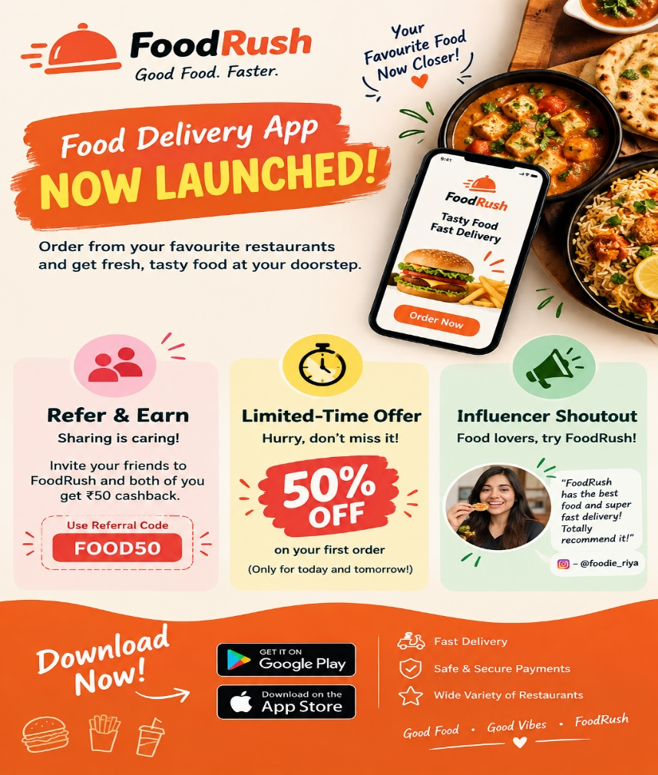

- List five types of online ads you’ve seen while using YouTube, Instagram, or any other app. For each, mention which platform you saw it on and what made it noticeable or skippable

TYPE OF AD | PLATFORM | WHY I NOTICED / SKIPPED IT
Video Ad | Youtube | I watched it because of a good offer. I skipped it because it was too long.
Photho Ad | Instagram | I noticed it because of attractive pictures.
Shopping Ad | Google | I noticed it because of low prices and discounts.
Story Ad | Instagram | I liked the short video but skipped boring ads.
Banner Ad | Mobile Games | I skipped it because it disturbed my game.

- Imagine you are launching a new playlist feature for a music app like Spotify. Write a short plan (5-6 lines) describing how you would use online marketing concepts (SEO, social media posts, email campaigns, influencer partnerships) to promote this feature.

Online Marketing Plan for Spotify
- SEO: Use music keywords on Google.
- Social Media: Share videos on Instagram.
- Email: Send emails to tell users about the new feature.
- Influencers: Ask famous people to promote it.
- Offers: Give special offers to users.
- Goal: Get more people to use the new feature

